Basic user interaction was the goal of our sixth laboratory assessment for the midterm period in CSPC223, “Programming Languages.”

# Submission

## Output

The source code is set up to show both dialog boxes...

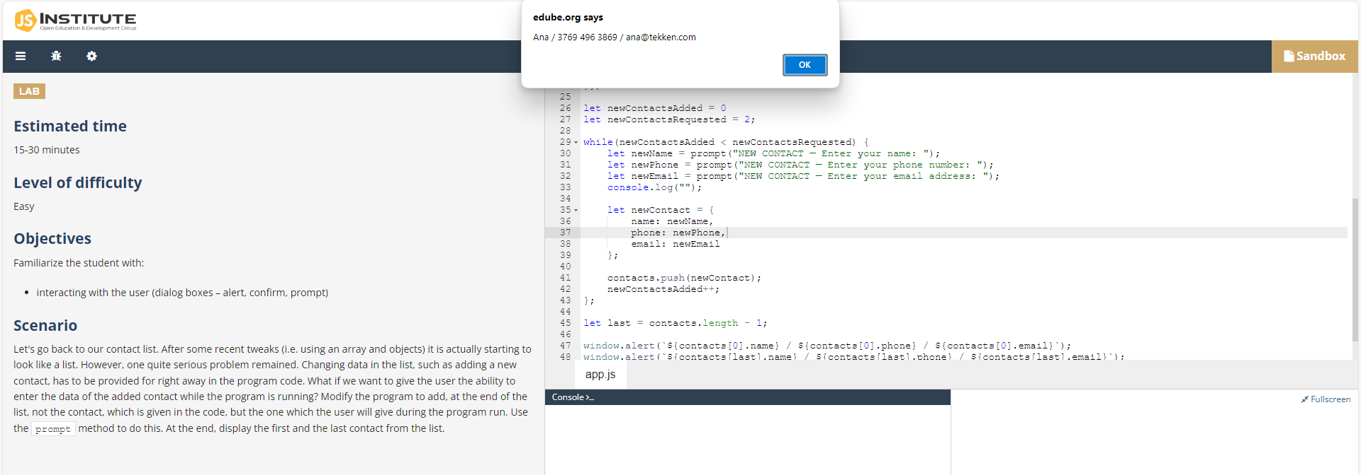...and log messages to the terminal.

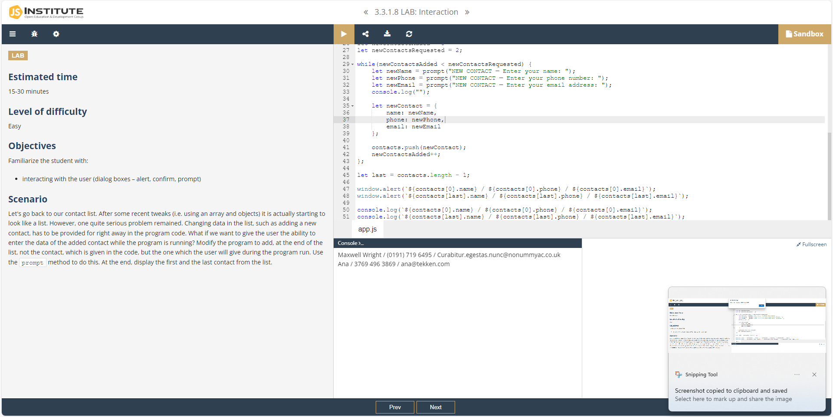The two messages sent contain the first, and the last, entries in the `contacts` array.

## Code Input

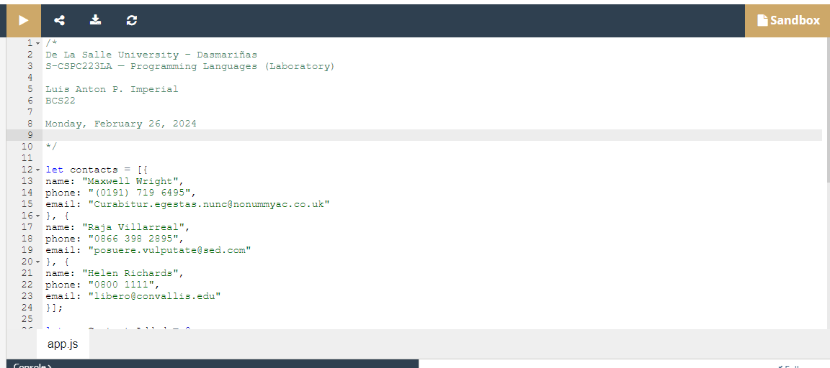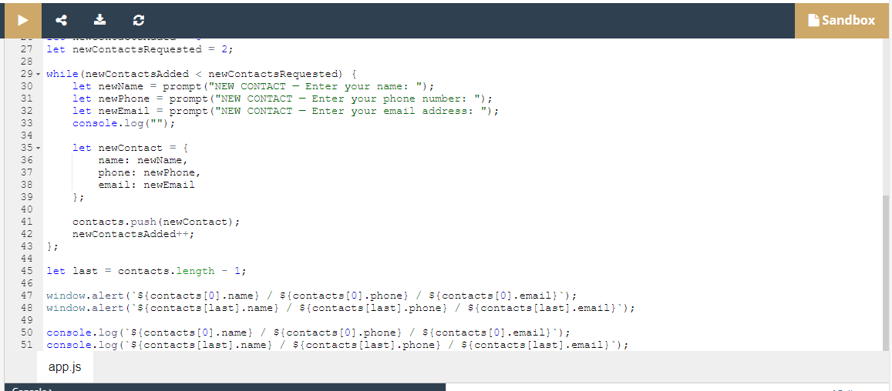

# Appendix

## Code

/*

De La Salle University – Dasmariñas

S-CSPC223LA — Programming Languages (Laboratory)

Luis Anton P. Imperial

BCS22

Monday, February 26, 2024

*/

let contacts = [{

name: "Maxwell Wright",

phone: "(0191) 719 6495",

email: "Curabitur.egestas.nunc@nonummyac.co.uk"

}, {

name: "Raja Villarreal",

phone: "0866 398 2895",

email: "posuere.vulputate@sed.com"

}, {

name: "Helen Richards",

phone: "0800 1111",

email: "libero@convallis.edu"

}];

let newContactsAdded = 0

let newContactsRequested = 2;

while(newContactsAdded < newContactsRequested) {

let newName = prompt("NEW CONTACT — Enter your name: ");

let newPhone = prompt("NEW CONTACT — Enter your phone number: ");

let newEmail = prompt("NEW CONTACT — Enter your email address: ");

console.log("");

let newContact = {

name: newName,

phone: newPhone,

email: newEmail

};

contacts.push(newContact);

newContactsAdded++;

};

let last = contacts.length - 1;

window.alert(`${contacts[0].name} / ${contacts[0].phone} / ${contacts[0].email}`);

window.alert(`${contacts[last].name} / ${contacts[last].phone} / ${contacts[last].email}`);

console.log(`${contacts[0].name} / ${contacts[0].phone} / ${contacts[0].email}`);

console.log(`${contacts[last].name} / ${contacts[last].phone} / ${contacts[last].email}`);

## Links

* “contactSelect.js”: [contactSelect.js](https://dlsudphl-my.sharepoint.com/:u:/g/personal/ilp0824_dlsud_edu_ph/EdeNQNgPW_hAgg6bQLiC3VIBjYJUTnD0yjdymznAw0OMaQ?e=mY9wqd)
* Instructions (via Schoolbook): <https://dlsud.edu20.org/files/6511997/Screen_Shot_2024-02-26_at_7.54.50_AM.png?lmsauth=6676eaa70c867e1e53e8a1d05566ac5d20922ec0>
* Instructions (via NetAcad): <https://edube.org/learn/jse1-1-0/lab-interaction>